Case 17-AM,C-Taino-Zemi-Head-Anthropomorphic-Type 3-Fewkes-1000-1500
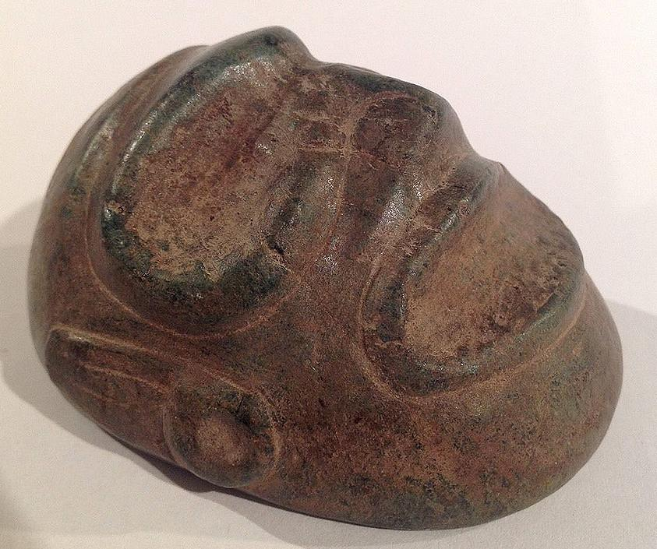
Case No.:
Accession Number:
Formal Label:
Display Description:
Stone heads were made for ancestor worship. The tradition originated from keeping skulls of important headmen. The Taino took the concept to an artistic level. This rather content characterization has well defined eye and mouth surrounds and wears ear spools. Concentric circle on back of head symbolized the sun and life's energy.
LC Classification:
Date or Time Horizon: 1000-1500
Geographical Area: Dominican Republic
Map:
GPS Coordinates:
Cultural Affiliation:
Medium:
Dimensions: 7.5cm or 2.9".
Weight:
Provenance:
Condition:
Discussion:
References:

